Brief 2

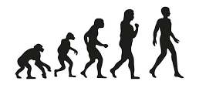
Evolution – Tasha and Théïa

- Start with one exercise, you can take this from the list in brief 1 or another one that you know.
- Complete the first movement correctly and every rep after that evolve it further and further from its origin.
- End the sequence with one rep of the original movement

Rigid/soft – Eevi and João

- This brief is quite improvisational and more ‘dance-like’
- Experiment with contrasting tensions and textures
- Imagine you are fluid water, and then you have been frozen. You are a tall flower and then over time you wilt etc
- Textures relating to sports – tense muscle, hard rigid steel, stretchy elastic bands, crumbly protein powder, fluid water, dry chalk, squidgy fat

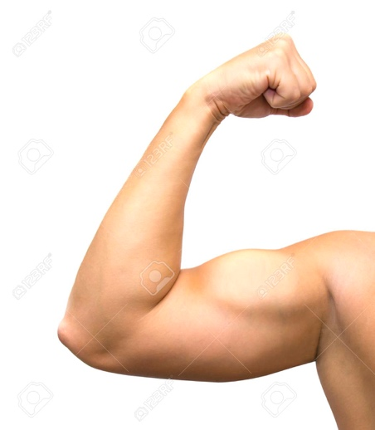

Flexin’ – Emma and Yuma

- Choose a body part – arm, leg, stomach, shoulders, bum etc.
- Try to position the camera so that the body part is the main focus like this ->
- Try to capture the muscle without clothes covering it, so you can see the muscles, skin and bones.
- You can be more traditional with the movements like this -> or flex in other ways. You could try evolving the flex like the ‘evolution’ task above
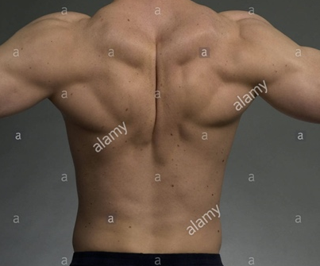

Technical notes:

- Please film with a background that is as blank as you can find. I know this is difficult if you’re stuck at home. You don’t have to film inside your home, you can do it in a studio (if you have access) or outside if warm enough!
- Try to be aware of the frame of the image

